PREPRINT · MEDRXIV · NOT PEER-REVIEWED

Executable AI-QSP model of autoimmune gastritis reveals biomarker identifiability limits from cross-sectional literature calibration.
Igor Goryanin¹,² Irina V. Goryanin²
¹ University of Edinburgh, UK ² IQANOVA Ltd, Edinburgh, UK Correspondence: goryanin@ed.ac.uk
Status labels (mandatory). Model evolution state CORE_CALIBRATED for the gastrin subsystem; surrogate / cross-sectional-calibrated, not clinically validated. All temporal-dynamic and therapeutic results are hypothesis-generating.
Model & run metadata

Model ID | AIG_VHT_v1_1_CORE_CALIBRATED
Pipeline | IQANOVA AI-QSP v2.21 (fidelity / identifiability / claim-control gates)
Input route | UPDATE_WITH_LDI (calibration of prior ASSUMED_STRUCTURE build)
Validation tier | Tier 1 (surrogate / cross-sectional-calibrated) for gastrin, CgA, B12; Tier 0 (hypothesis-generating) for dynamics & therapy
Calibration data | Digitised published cross-sectional cohort means — no patient-level trajectories, no synthetic trial arms
Fit quality | Overall log-RMSE = 0.16 (gastrin / CgA / B12; 15 anchors)
Well-identified | Ka (acid-feedback threshold), 95% CI 0.43–0.58
Moderately identified | G_max (gastrin ceiling), B12 scale; Hill steepness a sharp switch (hG ≥ 4.3)
Non-identifiable | ECL_max, Kecl (from cross-sectional CgA) → longitudinal CgA or ECL histology required
Predicted only | APCA arm (immune priors fixed): reproduces early-active N-of-1 titre, not cohort severity trend
Software | libSBML 5.21 (0 fatal errors) · libRoadRunner 2.9 · SciPy
Deliverables | SBML (2 branches) · SED-ML · OMEX · figures · SHA-256 manifest

Structured abstract
Background. Autoimmune gastritis (AIG) is a corpus-restricted, CD4⁺ T-cell–mediated destruction of gastric parietal cells producing a stereotyped biomarker cascade — hypochlorhydria, compensatory hypergastrinaemia, enterochromaffin-like (ECL) cell hyperplasia with type-1 neuroendocrine-tumour risk, and intrinsic-factor–dependent vitamin B12 and iron failure. Despite a well-mapped mechanism, no executable QSP model of the coupled loop exists, and the field lacks a transparent test of which parameters are identifiable from routinely reported biomarkers.
Methods. Using a gated AI-QSP pipeline, we assembled an eight-state SBML model coupling a parietal–effector-T–regulatory-T–autoantibody core to an acid→gastrin→ECL trophic loop and intrinsic-factor–gated B12/iron output modules. Because published AIG data are overwhelmingly cross-sectional by atrophy stage, we calibrated the model's steady-state manifold against digitised literature cohort means (gastrin, chromogranin A [CgA], vitamin B12) along a parietal-mass severity axis, holding immune parameters at literature priors. Identifiability was assessed using profile likelihood with a χ²₁ 95% threshold, corresponding to Δcost = 1.92. A publicly disclosed case (anti-parietal antibody [APCA] 103 U/mL, early atrophy-confined disease) served as an out-of-sample N-of-1 overlay.
Results. The gastrin, CgA and B12 arms were reproduced with an overall log-RMSE of 0.16. Profile likelihood identified the acid-feedback threshold (Ka) as well-constrained (95% CI 0.43–0.58), the gastrin ceiling and B12 scale as moderately constrained, and the acid-feedback steepness as a sharp switch (Hill ≥ 4.3). The ECL-hyperplasia parameters were non-identifiable from cross-sectional CgA alone. The antibody arm, predicted with fixed immune priors, reproduced the early-active N-of-1 titre (98 vs 103 U/mL) but failed to reproduce the cohort severity trend, exposing a specific structural gap.
Conclusions. An AI-assembled QSP model reproduces the AIG biomarker cascade under literature-anchored cross-sectional calibration, and its profile-likelihood analysis converts vague uncertainty into a precise experimental agenda: the binding constraint is data identifiability, not biological plausibility. The N-of-1-to-cohort tension in the antibody arm is itself the model's most actionable output.

Introduction
The pathophysiology of AIG is unusually well characterised qualitatively: autoreactive CD4⁺ Th1/Th17 cells target the gastric H⁺/K⁺-ATPase, driving parietal-cell apoptosis via Fas/FasL, perforin–granzyme and complement, with B-cell autoantibody and defective regulatory-T-cell suppression as amplifiers. The resulting hypochlorhydria removes gastrin negative feedback, and sustained hypergastrinaemia is trophic for ECL cells, coupling the autoimmune lesion to neuroendocrine neoplasia. This qualitative clarity has not been translated into an executable, calibrated model that states — quantitatively and falsifiably — which of its parameters the available clinical data can pin down. We address that gap with a gated AI-QSP workflow [11], deliberately foregrounding identifiability over fit.

Methods

Model structure
Eight dynamic states across three compartments (corpus: parietal mass P, ECL mass, effector T Teff, regulatory T Treg; circulation: autoantibody Ab, gastrin G, B12, iron Fe), with gastric acid output and intrinsic factor taken proportional to parietal mass (Acid = IF = P). The model structure, its regulatory couplings, the mapped observables and the candidate therapeutic levers are summarised in Figure 1; the full ordinary-differential-equation system and all parameters are provided in the SBML model and supplementary material.

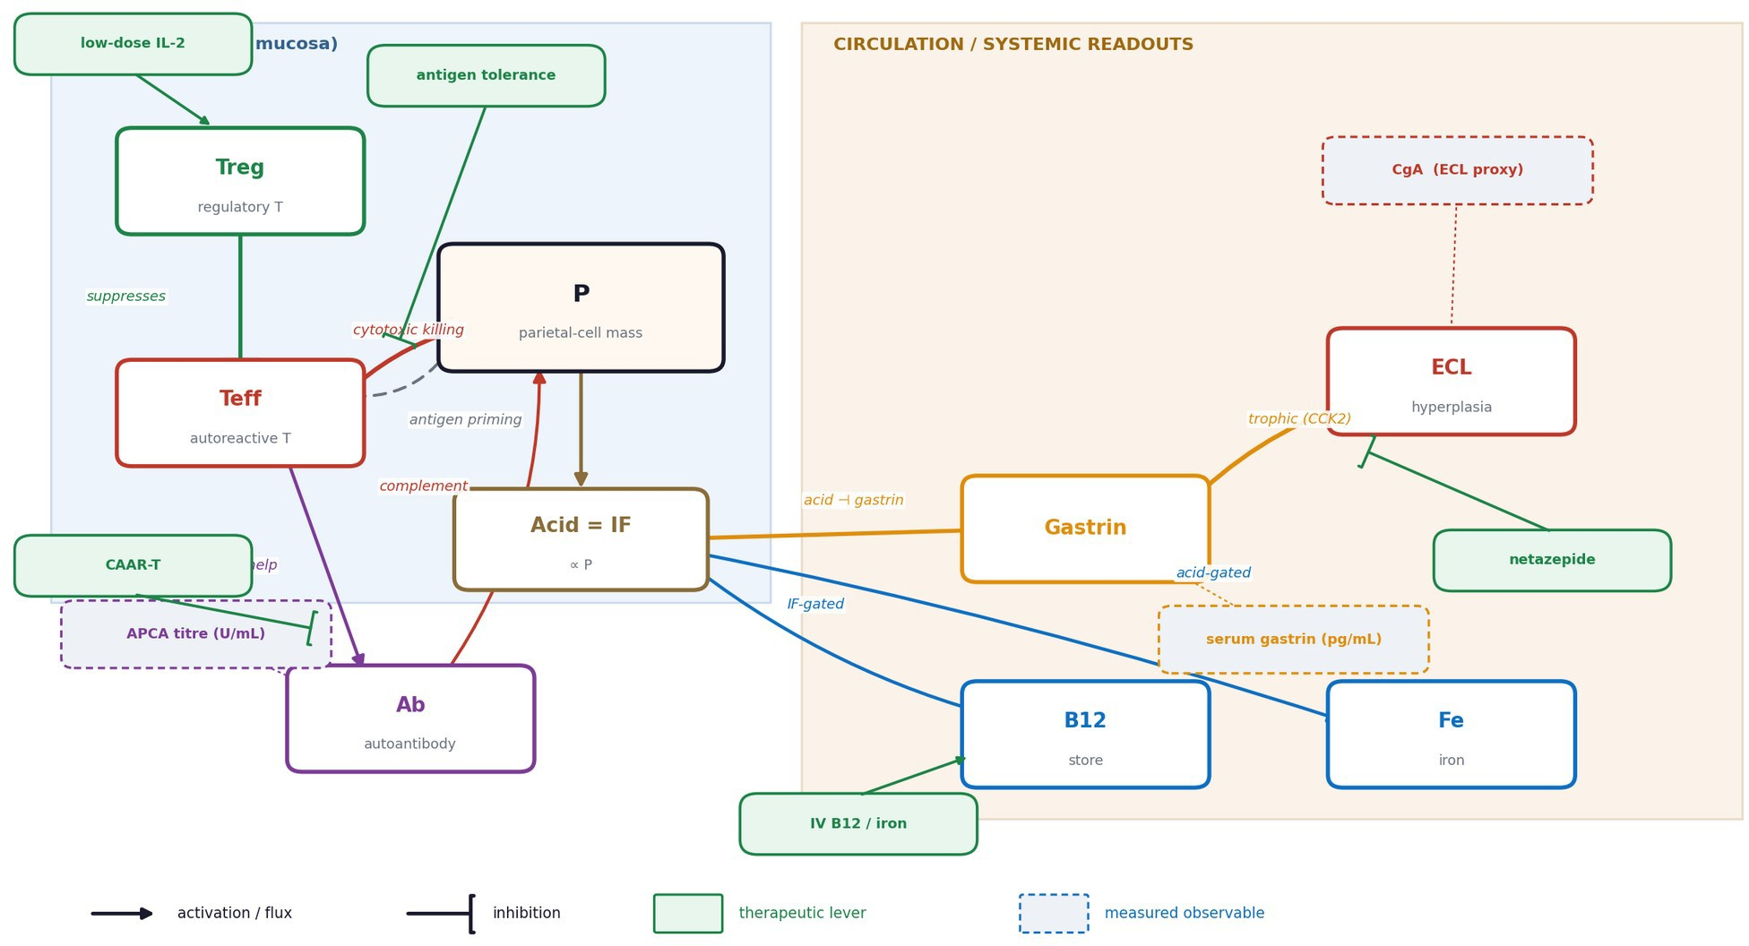
Figure 1. AIG-VHT model schematic. Corpus module (parietal mass P, ECL cells, autoreactive Teff, regulatory Treg) and circulation module (autoantibody, gastrin, B12, iron). Parietal cells are both immune target and antigen source, making the autoimmune loop self-limiting as atrophy advances; loss of parietal (acid/intrinsic-factor) output releases gastrin negative feedback, and gastrin is trophic for ECL cells. Solid arrows = activation/flux; bracketed heads = inhibition; green tags = therapeutic levers (low-dose IL-2, antigen-specific tolerance, netazepide, CAAR-T, parenteral B12/iron); dashed blue badges = measured observables (serum gastrin, chromogranin A as an ECL proxy, anti-parietal antibody titre, vitamin B12).
A structural feature worth naming: because parietal cells are both the immune target and the antigen source (P appears in the Teff priming term), the autoimmune loop is self-limiting as atrophy advances — an emergent property consistent with burnt-out late AIG.

Data sources and digitisation
Published cohort means were digitised as steady-state anchors along a parietal-mass severity axis: serum gastrin from control (~46 pg/mL) through PCA⁺ atrophic (~476 pg/mL) and pernicious anaemia (~699 pg/mL) to AIG-with-neoplasia ranges (weighted ~812 pg/mL; individual cohort means to ~1400 pg/mL); CgA stratified by ECL status (~171 ng/mL without vs ~303 ng/mL with hyperplasia; ECL⁺ threshold ~183 ng/mL); and B12 spanning mid-normal to deficiency (<200 pg/mL). A diagnostic gastrin threshold of 355 pg/mL anchors the mid-severity region. Data are cross-sectional; no per-patient trajectories or synthetic trial arms were used or generated.

Calibration and identifiability
Steady-state observable functions (gastrin(P), CgA∝ECL(P), B12(P)) were fit by weighted least squares (weights from reported SD or 15–25% of the mean). Immune parameters were held at literature priors; the autoantibody arm was therefore predicted, not fitted (single output scale only). Identifiability used profile likelihood

Software and reproducibility
The model was encoded in SBML L3V2 [14] (libSBML 5.21; zero fatal validation errors), consistent with our SBML-standardised systems-biology infrastructure [12]; simulation used libRoadRunner 2.9 [15], with calibration and profiling in SciPy, following the AI-QSP surrogate-modelling and digital-twin methodology

described previously [11]. The full COMBINE/OMEX archive accompanies this preprint with a SHA-256 manifest.

Results

Calibration
The gastrin, CgA and B12 arms were reproduced with an overall log-RMSE of 0.16 (gastrin RMSE 91 pg/mL over 46–900; CgA 98 ng/mL over 40–450; B12 74 pg/mL over 150–500). The calibrated gastrin response is a sharp acid-feedback switch: near-normal until parietal mass falls below a threshold, then a steep rise to a ceiling consistent with pernicious-anaemia-level hypergastrinaemia.
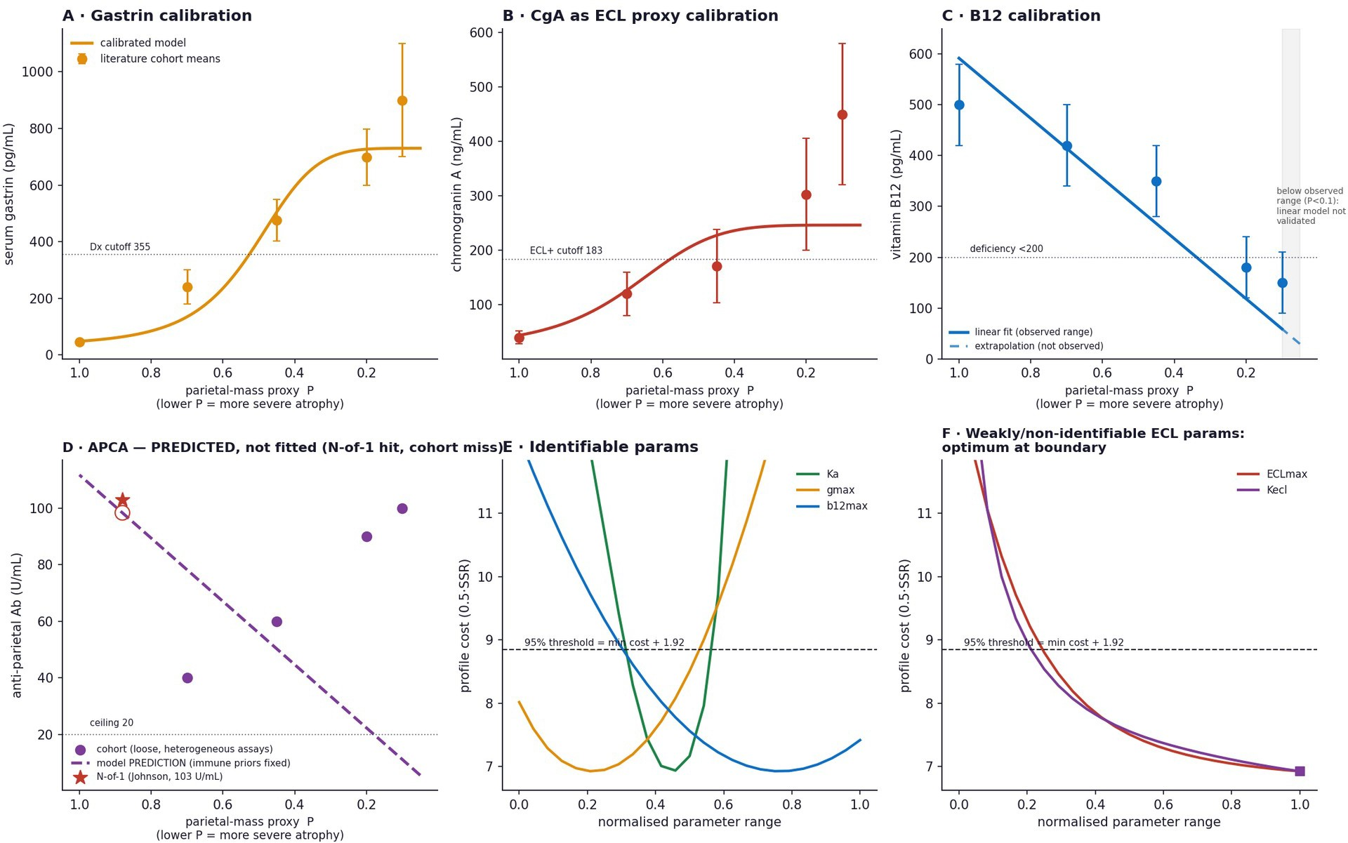
Figure 2. (A–C) Calibrated steady-state fits through digitised literature cohort means for gastrin, chromogranin A (as an ECL proxy) and vitamin B12 along the parietal-mass severity axis (lower P = more severe atrophy); the B12 fit is solid over the observed range and dashed where extrapolated below it. (D) APCA predicted with fixed immune priors (predicted, not fitted): the N-of-1 case (red star, 103 U/mL) is reproduced (98 U/mL) but the cohort severity trend is not. (E) Identifiable parameters (Ka, G_max, B12 scale); dashed line = 95% threshold (min cost + 1.92). (F) Weakly/non-identifiable ECL-hyperplasia parameters — profile optima drift to the parameter boundary rather than forming an interior minimum.

Identifiability
Profile likelihood separates what the data constrain from what they cannot constrain. The acid-feedback threshold Ka is well-identified (95% CI 0.43–0.58). The gastrin ceiling (~600–900 pg/mL) and the B12 scale are moderately identified. The acid-feedback steepness saturates — a sharp switch (Hill ≥ 4.3) is required but its exact value is not fixed. The ECL-hyperplasia parameters are non-identifiable from cross-sectional CgA: their profile optima drift to the parameter boundary rather than forming an interior minimum. The actionable implication is specific: the neoplastic-risk arm cannot be parameterised from cross-sectional CgA and requires longitudinal CgA trajectories or direct ECL histological counts.

The N-of-1-to-cohort bridge
With immune parameters fixed at priors, the model predicts the antibody titre of a single early-active case (near-normal parietal mass, APCA 103 U/mL) almost exactly (98 U/mL), yet predicts a declining APCA with advancing atrophy, opposite to the loosely-reported cohort trend. This is a structural diagnosis, not a fitting failure: antigen-abundance-driven priming reproduces the high titre of early active disease and the decline of end-stage burnt-out disease, but omits the clonal-activation/seroconversion term that drives the initial rise. Assay heterogeneity across APCA reports (units vs titres) compounds this and is a genuine data limitation.

Therapeutic scenarios (hypothesis-generating)
Scenario simulations, presented strictly as directions of effect, separate three intervention classes: replacement (parenteral B12, IV iron) corrects the output arms while leaving parietal mass, antibody, gastrin and ECL unchanged; gastrin/CCK2 antagonism (netazepide) collapses the ECL/neoplastic arm without altering the autoimmune core; and only immune-directed levers (regulatory-T expansion, antigen-specific tolerance) move parietal mass, with antigen-specific tolerance outperforming broad Treg expansion on the antibody arm. The model further predicts that antibody-directed clearance alone is insufficient without a T-cell-directed arm.
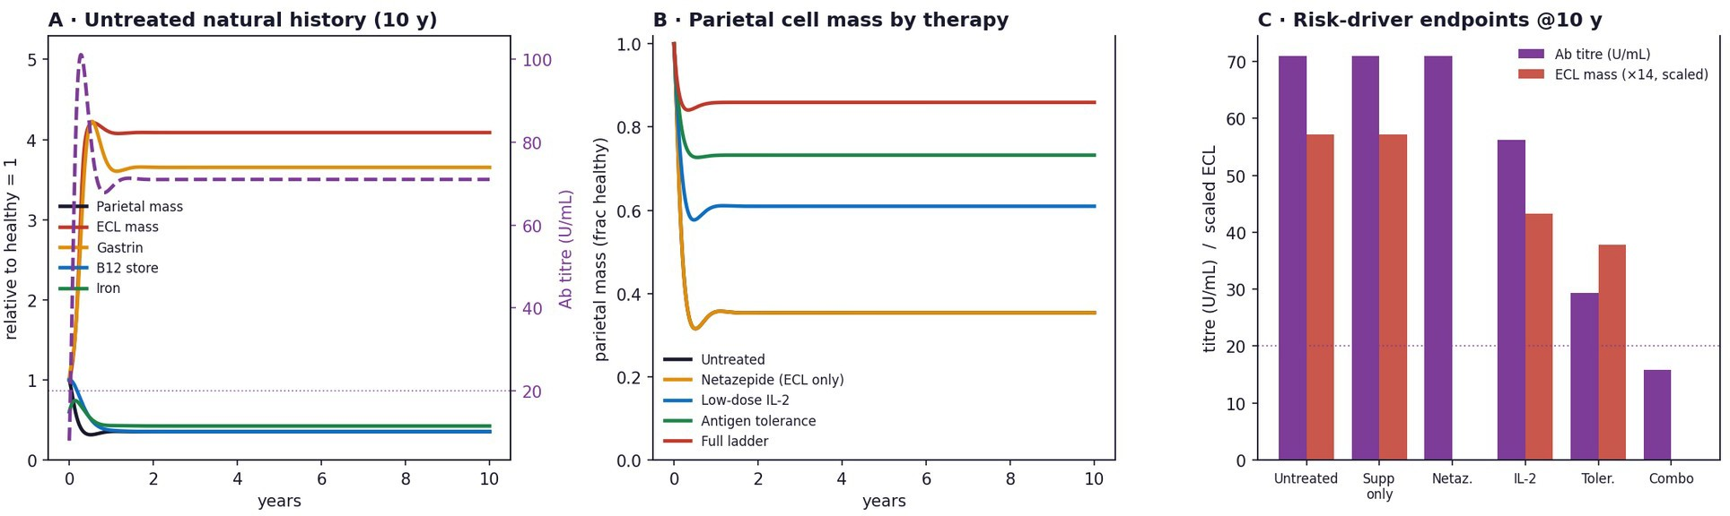
Figure 3. Hypothesis-generating therapy scenarios (uncalibrated dynamics). (A) Untreated natural history. (B) Parietal-mass rescue by immune-directed therapy. (C) Risk-driver endpoints (antibody titre, ECL mass) at 10 years across intervention classes.

Discussion
A transparent, gated pipeline produced an executable, literature-anchored model of the AIG cascade and, through profile likelihood, an explicit map of parameter identifiability that converts uncertainty into an experimental agenda.
Two rate-law errors were caught by the pipeline's fidelity gates during assembly — an inverted gastrin-feedback steady state and an antibody scale an order of magnitude below the clinical range; both were corrected and re-verified. The antibody arm remains structurally incomplete (no activation term), which the N-of-1 analysis exposes.
The ECL non-identifiability and the antibody trend reversal are structural, not parametric; no amount of fitting to cross-sectional data resolves them. For this system, the binding constraint is data identifiability.
Tier 1 (surrogate / cross-sectional-calibrated) for the gastrin/CgA/B12 steady-state observables; Tier 0 / hypothesis-generating for all dynamics and therapy — a distinction consistent with model-credibility frameworks [16] and current AI-QSP validation guidance [11]. No clinical or regulatory claim is made.
What this model can and cannot claim. The model supports steady-state biomarker interpretation, identifiability analysis and experimental-design prioritisation. It does not support clinical diagnosis, treatment selection, patient-specific prognosis or validated digital-twin use.

Single-organ scope (thyroid pole exogenous); a parietal-mass proxy stands in for a true temporal axis; parietal regeneration assumed reversible; APCA assays heterogeneous; calibration to cross-sectional cohort means, not patient-level trajectories.
Longitudinal cohorts with paired gastrin/CgA/APCA/B12 and histology would enable dynamic calibration and could test the model's falsifiable predictions: self-limiting autoimmune drive with advancing atrophy; an early therapeutic window for regulatory-T-directed intervention; netazepide reducing ECL/CgA without altering titre or B12; and insufficiency of antibody-directed clearance alone.

Data and code availability
SBML (assumed and calibrated branches), SED-ML, OMEX archive, calibration and profile-likelihood scripts, the digitised anchor table and figures are available from www.iqanova.org as supplementary files with a SHA-256 manifest.
Ethics / data statement: The N-of-1 value was taken from publicly disclosed, non-interventional information; no identifiable clinical record was accessed; the result is not used for diagnosis or treatment.

AI-use statement
Model assembly, calibration, identifiability analysis, figure generation and drafting were performed with an AI-QSP pipeline (IQANOVA v2.21) under explicit fidelity, identifiability and claim-control gates, with human oversight. Literature values were digitised from published sources cited below; no synthetic patient data or trial arms were generated. AI assisted assembly and checking, but all equations, parameters, literature anchors, SBML files and profile-likelihood outputs are inspectable and reproducible.

Competing interests
I.G. is Founder and CEO of IQANOVA Ltd; I.V.G. is a Director of IQANOVA Ltd. IQANOVA develops the AI-QSP pipeline used in this study. The authors declare no other competing interests.

Funding

This work was internally supported by IQANOVA Ltd. No external funding was received.

Author contributions
I.G.: conceptualization, methodology, software, formal analysis, investigation, writing — original draft. I.V.G.: methodology, validation, writing — review & editing. Both authors read and approved the final manuscript.

References
- Lenti MV, Rugge M, Lahner E, Miceli E, Toh BH, Genta RM, De Block C, Hershko C, Di Sabatino A. Autoimmune gastritis. Nat Rev Dis Primers. 2020;6(1):56. doi:10.1038/s41572-020-0187-8.
- Castellana C, Eusebi LH, Dajti E, Iascone V, Vestito A, Fusaroli P, Fuccio L, D'Errico A, Zagari RM. Autoimmune atrophic gastritis: a clinical review. Cancers. 2024;16(7):1310. doi:10.3390/cancers16071310.
- Massironi S, Oriani E, Dell'Anna G, Danese S, Facciotti F. The autoimmune gastritis puzzle: emerging cellular crosstalk and molecular pathways driving parietal cell loss and ECL cell hyperplasia. Cells. 2025;14(20):1576. doi:10.3390/cells14201576.
- D'Elios MM, Bergman MP, Azzurri A, et al. H+,K+-ATPase (proton pump) is the target autoantigen of Th1-type cytotoxic T cells in autoimmune gastritis. Gastroenterology. 2001;120(2):377–386. doi:10.1053/gast.2001.21187.
- Relevance of pepsinogen, gastrin, and endoscopic atrophy in the diagnosis of autoimmune gastritis. Sci Rep. 2022;12. doi:10.1038/s41598-022-07947-1. (Serum gastrin diagnostic cutoff 355 pg/mL.)

- Wang YQ, Liu ZJ, et al. Do serum biomarkers correlate to the risk of gastric lesions in patients with autoimmune gastritis? A systematic review and meta-analysis. Clin Res Hepatol Gastroenterol. 2025; article PII S2210-7401(25)00199-8. (Weighted-mean gastrin 811.53 pg/mL for NET, 240.02 pg/mL for gastric polyps.)
- Serum gastrin levels are associated with prevalent neuroendocrine tumors in autoimmune metaplastic atrophic gastritis. 2025. PMID 39588964. (Gastrin 679.5 vs 1859.8 pg/mL without vs with gNET.)
- Herold Z, Doleschall M, Somogyi A, et al. Serum chromogranin A level continuously rises with the progression of type 1 diabetes, and indicates the presence of both enterochromaffin-like cell hyperplasia and autoimmune gastritis. J Diabetes Investig. 2020;11(4):865–873. doi:10.1111/jdi.13203. (CgA ECL⁺ cutoff 183.35 ng/mL.)
- Kalkan Ç, Karakaya F, Soykan İ. Factors associated with elevated serum chromogranin A levels in patients with autoimmune gastritis. Turk J Gastroenterol. 2016;27(6):515–520. PMID 27852542. (CgA 171.17 ± 67.3 ng/mL without vs 303.3 ± 102.82 ng/mL with ECL-cell hyperplasia.)
- Autoimmune metaplastic atrophic gastritis. Merck Manual, Professional Edition; 2025. (Gastrin frequently >1000 pg/mL in achlorhydria-driven hypergastrinaemia.)
- Goryanin I, Goryanin I, Demin O. Revolutionizing drug discovery: integrating artificial intelligence with quantitative systems pharmacology. Drug Discov Today. 2025;30:104448. doi:10.1016/j.drudis.2025.104448. PMID 40774584.
- Goryanin I, Slovianov L, Checkley S, Goryanin I. EHMN 2026: a thermodynamically refined, SBML-standardised human metabolic network for genome-scale analysis and QSP integration. Metabolites. 2026;16(4):236. doi:10.3390/metabo16040236.
- Raue A, Kreutz C, Maiwald T, et al. Structural and practical identifiability analysis of partially observed dynamical models by exploiting the profile likelihood. Bioinformatics. 2009;25(15):1923–1929. doi:10.1093/bioinformatics/btp358.
- Hucka M, Finney A, Sauro HM, et al. The systems biology markup language (SBML): a medium for representation and exchange of biochemical network models. Bioinformatics. 2003;19(4):524–531. doi:10.1093/bioinformatics/btg015.
- Somogyi ET, Bouteiller JM, Glazier JA, König M, Medley JK, Swat MH, Sauro HM. libRoadRunner: a high performance SBML simulation and analysis library. Bioinformatics. 2015;31(20):3315–3321. doi:10.1093/bioinformatics/btv363.
- American Society of Mechanical Engineers. Assessing credibility of computational modeling through verification and validation: application to medical devices. ASME V&V 40-2018. New York, NY: ASME; 2018.

